Intelligent IOT based Car Parking using

An Android Application

Meet Shah1, Hanisha Jamtani2, Krishna Vanvari3, Mrs. Sunita Sahu4,

*Department of Computer Engineering,*

*VESIT*

*Mumbai, India*

[meetshah15@gmail.com](mailto:Meetshah15@gmail.com)

[hanisha.jamtani@ves.ac.in](mailto:Hanisha.jamtani@ves.ac.in)

[krishna.vanvari@gmail.com](mailto:Krishna.vanvari@gmail.com)

[sunita.sahu@ves.ac.in](mailto:Sunita.sahu@ves.ac.in)

***Abstract*— Parking system is a critical arena that requires a revolutionary change with the growth of technology that is needed to support this change. This paper presents the design and implementation of the prototype developed of the car parking automation system based on IOT, that provide robust searching and booking feature of a parking lot for a vehicle owner. The proposed system consists of IR sensors, embedded web-server, and a mobile application. Low cost sensor network is deployed on the prototype which represents a parking area. Initially, the existence of objects being sensed provides significant data for parking slot detection. Secondly, sensor quality has a material correlation with the performance by the sensors deployed. From this, we propose a) the development of a topological sensor detection system b) Traditional server rather than cloud system that allows local data processing c) Application based UI interaction with the users of the system.**

***Keywords--Android application, IOT, Data Analytics, Web server, Arduino, IR proximity sensors, Object Detection, Visual studio***

1. Introduction

In today’s highly traffic congested cities, parking becomes a tedious task for the vehicle drivers consuming precious time and energy of the drivers. Eventually, it also results in fuel wastage and air pollution. According to recent reports and statistics, it is observed that traffic generated due to vehicles searching for parking spaces, takes up to 40% of the total traffic. Considering the situation, various efficient parking methodologies have been suggested. Few mechanisms used video camera sensors to gather information of the parking spaces [3],[14], although it’s an expensive reform to execute along with certain drawbacks resulting from the transmission issues in wireless networks. Today, wireless sensors have emerged successfully due to its simple and low expense solutions [5],[6],[8].

Sensor network is an integration of tiny devices which have wireless connections. For our purpose, INFRARED sensors are used which usually are low cost, user friendly and have fast obstacle detection via infrared reflection. This wireless sensor network is useful to many fields including environmental supervision, security purposes, home and workplace surveillance, agricultural inspections, etc. As it observed that these sensors are used in many application, we used it for the detection of free parking slots.

The proposed system, runs on an android application which is developed to offer an interface to the user for reservation. The user can select the desired parking space and confirm the booking. The functionality of pre-booking a slot makes it quite easy and flexible for the user. Facilities like registration, login and online payment are embedded in the application to make it completely automated. At the backend, the user details are updated on the database. A web server is integrated to pass the user information to the database. Moreover, the entry and exit time of the vehicle driver is recorded for the purpose of payment. The amount to be paid is proportional to the total time the vehicle parked. Another functionality tells that the vehicle reservation will be cancelled automatically if it does not enter in the specified time period. To achieve this, a timer is set which goes on until the pre-defined time (e.g. 20 minutes) is reached. If the user fails to enter within the time, reservation will be withdrawn. The user will be notified with the same. Analytics will be conducted to figure out the patterns which comprise of the peak hours and days for parking and suggesting a nearby place if the current premise is full.

The system promises to overcome the issues faced by the manual system by making it completely automated. The payment facility is made simpler by having an E-Wallet in the application, where the user can add and deduct money depending on the history. If the user does not have sufficient balance, a notification will be sent to add money for further transactions.

II. System Architecture

This section covers the detailed description including architecture and components used in the system. *“Fig 1”* below, illustrates the functionalities and connections with each other.

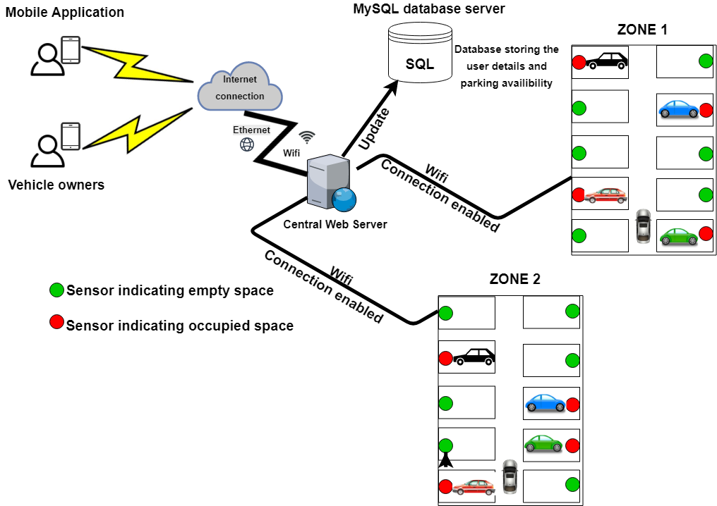

Fig.1. Overview of the proposed System Architecture

1. *Sensors*

The prototype has a collection of four IR sensors which are connected to the Arduino circuit. The responsibility of the sensor is to detect any kind of obstacle on the parking slot. Infrared radiations are used for vehicle detection. *“Fig 2”* shows the connection of the Infrared proximity sensors.

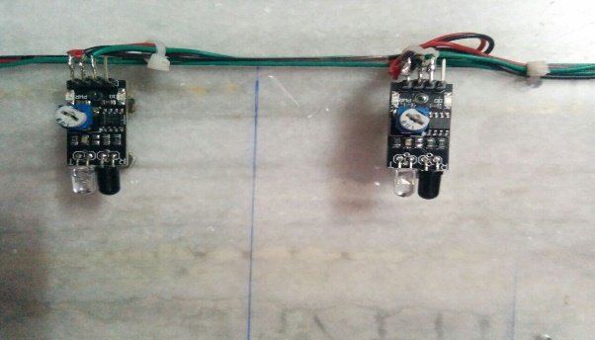

Fig. 2.  IR Proximity Sensors

These sensors are easy to deploy due to its specifications like 4.5 to 6 operating voltage, can give both, analog and digital output and having a small dimension of 0.6" x 1.3" x 0.5" inch (15.25 mm x 33mm x 12.7 mm).

*B.  Arduino circuit*

Arduino UNO is a microcontroller based on the datasheet ATmega328. It has 14 digital input and output pins, out of which 6 can be used as PWM outputs, 6 analog inputs, a USB connection, a 16 MHz ceramic resonator, an ICSP header, a power jack and a reset button. *“Fig 3”* shows the image of the Arduino UNO circuit deployed in our system.

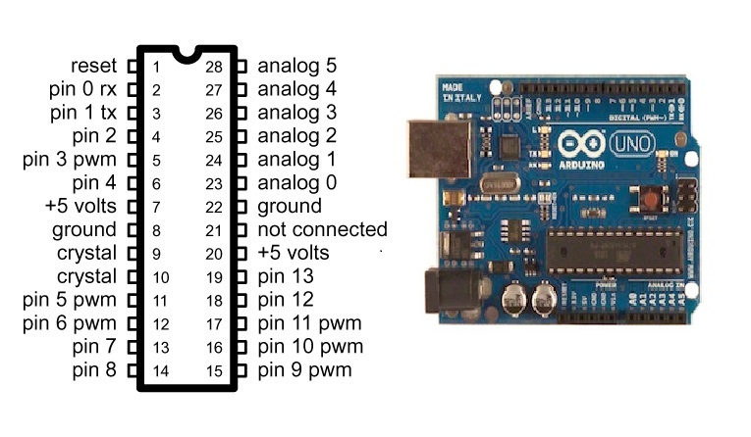

Fig.3. Arduino UNO pin configuration

We used Arduino UNO circuit in our prototype. Arduino is a well-known microcontroller to gather large amount of information and pass it to the web servers or cloud. Arduino gathers the parking slot availability status from the IR sensors and sends it to the web server which eventually updates the database.

*C*.  *Web Server*

Theweb server is the backbone of the whole system. It consists of all the data related to the user including the dynamic entry and exit time. The information received from the sensors is accessed in the database through the server. The parking status which is reserved, cancelled or available is updated in the database in real time. Nevertheless, it has a large capacity to accommodate a number of users.

*D*. *Mobile Application*

A mobile application stands as a interface between the user and our system enabling the user to perform booking operation in a parking lot. The user can simply book, cancel and make payments with the help of it. A wifi connection or 3G/4G network is needed for the application to work. Currently, an android application is developed which can be deployed for IOS as well in the future. *“Fig 4”* below, are few screenshots of the application named “CAR PARKING”.

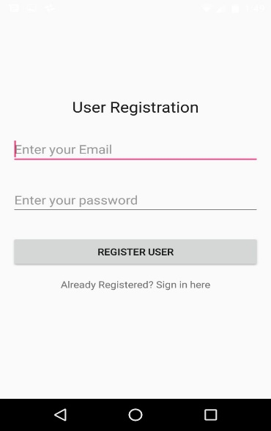 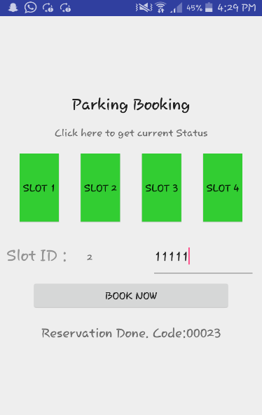

Fig.4. Android Application Screens

III. System Workflow

This section rightly explains the steps we carried out for the implementation of the prototype, having a parking lot connected to a working application. This prototype stands as an exclusive proof for the system in the real-time environment.

1. An android application is downloaded by the user for the reservation purpose. We have developed the application on Android Studio Development Kit, which enables parking availability check, reservation, and cancellation to the registered user. The user maintains a profile within the application which stores the user history.
2. The IR proximity sensors detect the availability of the slots and update the database which eventually notifies the application.
3. Arduino UNO is a computer in itself which sends the data detected from the sensors to the database through an HTTP server. The Arduino code has been developed on Arduino Create Agent.
4. The prototype has a display connected to Arduino which gives live availability status. *“Fig 5”* conveys that the parking slot 1 is full and 0 signifies that slot 2,3,4 are empty.
5. All the gathered data from the Arduino and the sensors are passed onto the database server. Microsoft SQL server .NET Framework is used at the backend to store the user information along with the slot availability including entry and exit time of the car.
6. After the user selects a slot for parking, he/she needs to reach the premises within a predefined time. The functionality of timer is also added which is used for the cancellation purpose.
7. The car owner is also provided with a unique code which is used for authentication.
8. The amount to be paid is calculated on the basis of the total time the car stayed in the premises.
9. E-Wallet is used for the purpose of payment wherein the user maintains a certain amount of balance which gets deducted in every visit.

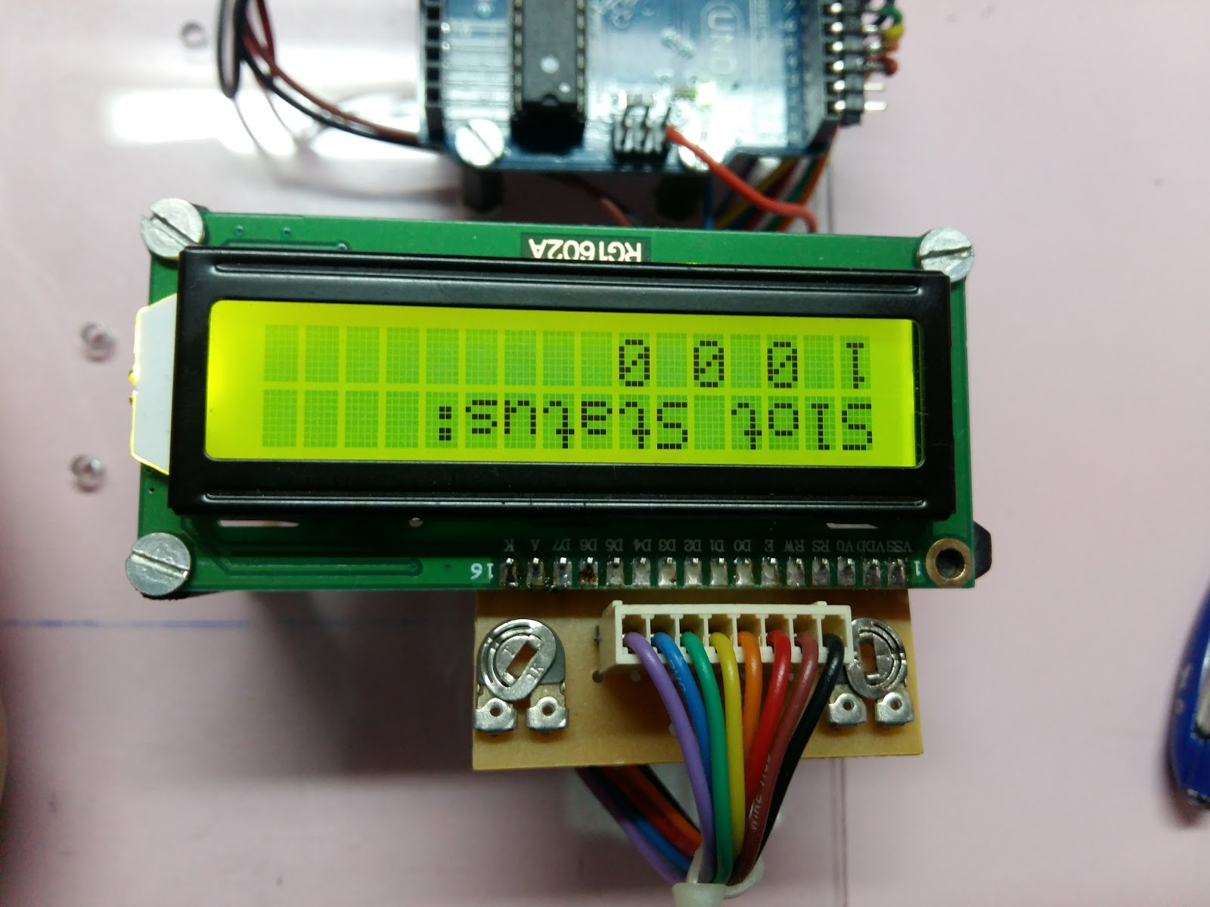

Fig.5. Android Application Screens

1. When there is no sufficient balance in the account, the user is notified to add electronic money into the wallet. This functionality proves to be easy and quick to the car owners.
2. If all the parking slots are full then a nearby parking area is suggested to the user. This feature saves ample amount of time of the user as it avoids the efforts taken to search a slot in a fully reserved area.
3. Moreover, analytics is carried out, to find the peak hours and days which can be further used for informing the application user about the same. *“Fig 6”* illustrates the flow of the modules.

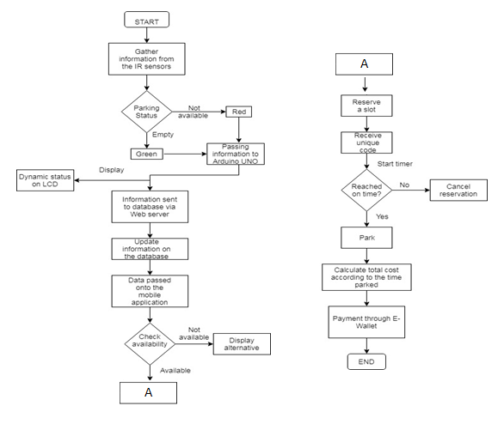  
Fig.6. System Flowchart

IV. Results

Experiments conducted on the prototype version enabled us to produce certain meaningful insights that can be obtained from a live system. Figure on the right is a scatter plot of the duration for which the vehicles entered and stayed in the parking lot. This information can be useful to create specific business plans.

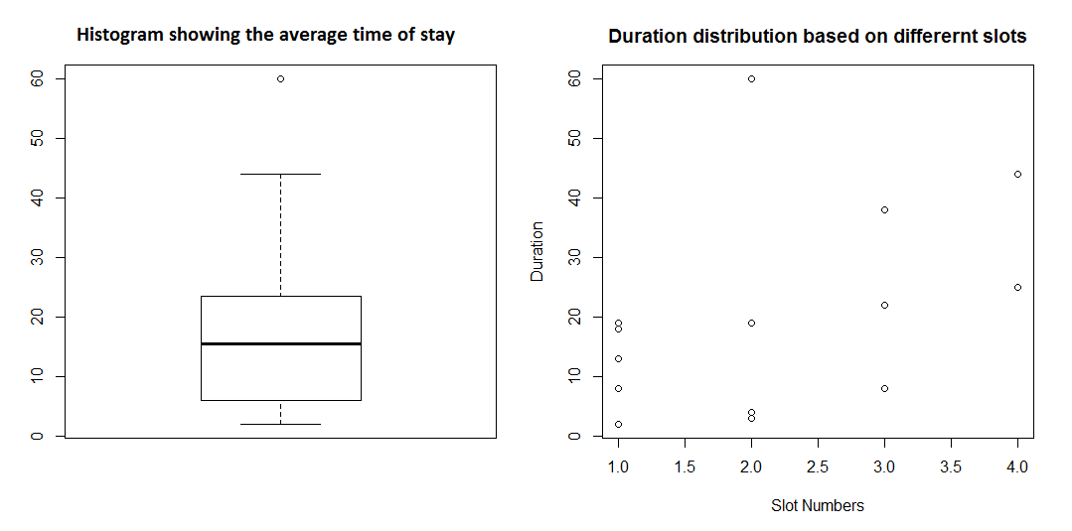

Fig.7. Duration distribution plot

Figure on the left shows a histogram plot to in correspondence to the duration of stay of each vehicle.

Furthermore, the booking data of the user can enlighten the peak hour information and the best and worst time of the day to visit a particular parking facility.

E-wallet facility using the application is also tested successfully using the prototype. The user has to have a minimum balance of 50 in order to make the booking. Also, payment calculation is done by the system and a bill is generated for the same.

V.  Conclusion

Metropolitan cities are in high need of such a system which promises to be completely automated. This paper presents a solution to an ongoing crucial problem in our everyday lives related to manual vehicle parking. We tried to implement a system which clears out the issue by making the whole system automated. This system stands out to be completely feasible and makes the task of the user quite convenient. The functionalities such as  E-Wallet is a unique element created for the vehicle owner’s to make this system reliable and user friendly. Moreover, the environmental factors are also affected in a good way, saving fuel and avoiding pollution. The proposed system in highly flexible, thereby making it suitable for enhancements. Additional functionalities like number plate recognition at the entrance for authentication can be deployed easily with the help of a camera. This system can be shifted to a cloud based system for large number of vehicle owners using the application.

References

1. F. Akyildiz, W. Su, Y. Sankarasubramaniam, E. Cayirci, "Wireless sensor networks: a survey," Computer Networks, vol. 38. Pp. 393 - 422,2002.
2. S. M. Bhadkumbhe , Anuj Narayan , Dnyaneshwar Narayan ,          Sarfraj Shaikh & Yogesh Kunjir.”Efficient Automated Smart Parking System using IOT Technologies” - *Imperial Journal of Interdisciplinary Research (IJIR) Vol-3, Issue-4, 2017*
3. Q. Wu, C. Huang, S. Y. Wang, W. C. Chiu, and T. Chen, "Robust Parking Space Detection Considering Inter-Space Correlation," iEEE international Conference on Multimedia and Expo, Beijing, China, July 2 - 5, pp. 659-662,2007.
4. M. Caliskan, D. Graupner, and M. Mauve, "Decentralized discovery of free parking places," in VANET '06: Proceedings of the 3rd international workshop on Vehicular ad hoc networks, New York, NY, USA, pp. 30 -29,2006
5. Laugier and F. Thierry. “Sensor-based control architecture for a car-like vehicle.” *Proceedings of IEEE/RSJ International Conference on Intelligent Robots and Systems, Volume 1, pages 216 –222, 1998.*
6. J. P. Benson, T. O'Donovan, P. O'sullivan, U. Roedig, and C. Sreenan,"Car-Park management using wireless sensor networks," in Proceedings of 31" IEEE coif. Local Computer Networks, Tampa, pp. 588-595. 2006.
7. G. Yan, W. Yang, D. B. Rawat and S. Olariu, "Smart Parking: A Secure and Intelligent Parking System," iEEE intelligent Transportation Systems Magazine, vol. 3(1), pp. 18 - 30,2011.
8. Laugier and F. Thierry. “Sensor-based control architecture for a car-like vehicle.” *Proceedings of IEEE/RSJ International Conference on Intelligent Robots and Systems, Volume 1, pages 216 –222, 1998.*
9. Shinde Smita N., Shinde Komal V., Nagpure Rashmila D. , Tupkar Avanti S., Prof. Ankoshe M. S "An Android Application for Parking Management and Dissemination System” - *International Journal of Scientific and Research Publications, Volume 2, Issue 10,Oct-2012-1 ISSN 2250-3153*
10. J. Dongjiu Geng, Yue Suo, Yu Chen, Jun Wen, Yongqing Lu, “Remote Access and Control System Based on Android Mobile Phone”, *Journal of Computer Applications, 2011.*
11. Mr. Basavaraju S R,”Automatic Smart Parking System using Internet of Things (IOT)”,*International Journal of Scientific and Research Publications, Volume 5, Issue 12, December 2015 629 ISSN 2250-3153*
12. *Hongwei Wang and Wenbo He, "A Reservation-based Smart Parking System," The First international Workshop on Cyber-Physical Networking Systems, pp. 70 I - 706, 2011.*
13. Laugier and F. Thierry. “Sensor-based control architecture for a car-like vehicle.” *Proceedings of IEEE/RSJ International Conference on Intelligent Robots and Systems, Volume 1, pages 216 –222, 1998.*
14. M.O. Reze M.F. Ismail A.A. Rokoni M.A.R. Sarkar, “Smart parking system with image processing facility”, *I.J. Intelligent Systems and Applications, 2012.*
15. Swee Meng Wong and Ming Xie.” Vision Functions for the Guidance of Smart Vehicle”.*Proceedings of the 9th International Conference on Advanced Robotics ('99 ICAR), Tokyo, Japan, October 25-27 1999.*
16. J. Wolff, T. Heuer, H. Gao, M. Weinmann, S. Voit and U. Hartmann, "Parking monitor system based on magnetic field sensors," *IEEE Conf. Intelligent Transportation Systems, 2006.*
17. Callum Rhodes, William Blewitt, Craig Sharp, Gary Ushaw and Graham Morgan “Smart Routing: A Novel Application of Collaborative Path-finding to Smart Parking Systems” *2014 IEEE 16th Conference on Business Informatics.*
18. K.Ashokkumar, Baron Sam , R. Arshadprabhu  , Britto,”Cloud Based Intelligent Transport System”,*2nd* *International Symposium on Big Data and Cloud Computing (ISBCC’15)*
19. Thanah Nam Pham , Ming-Fong Tsai , Duc Binh Nguyen , Chyi-Ren Dow ,  Der-Jiunn Deng, “A Cloud Based Smart Car Parking System Based on Internet of Things”, *Digital Object Identifier 10.1109/ACCESS.2015.2477299.*
20. C. Laugier and F. Thierry. “Sensor-based control architecture for a car-like vehicle.” *Proceedings of IEEE/RSJ International Conference on Intelligent Robots and Systems, Volume 1, pages 216 –222, 1998.*
21. J. P. Benson, T. O'Donovan, P. O'sullivan, U. Roedig, and C. Sreenan,"Car-Park management using wireless sensor networks," in Proceedings of 31" IEEE coif. Local Computer Networks, Tampa, pp. 588-595. 2006.